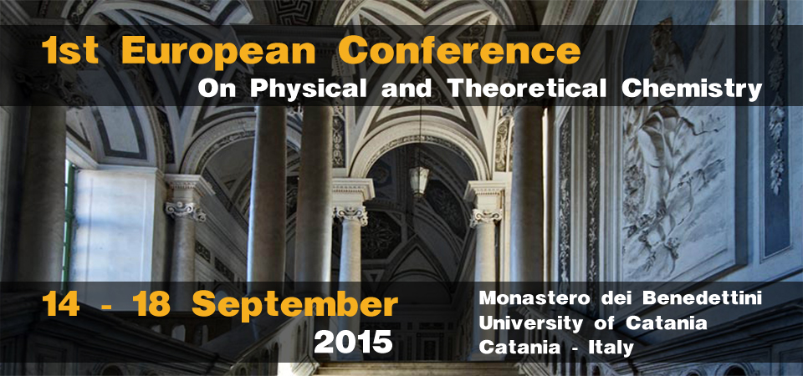

Registration form

Please fill out this form and send it back to europhyschem2015@unict.it.

PERSONAL DATA
(*) mandatory field
Title* | __________
First Name* | __________
Family Name* | __________
Company / Organization* | __________
Street* | __________
City* | __________
Post / Zip Code* | __________
Country* | __________
Telephone* | __________
Fax | __________
E-Mail* | __________

INVOICE DATA
(Optional)
Company Organization | __________
Street | __________
City | __________
Country | __________
Post / Zip Code | __________
Vat Number | __________

PAYMENT INFORMATION

(Please mark with an X one of the following options)

___ BANK TRANSFER
Beneficiary: Consorzio CSGI, Via della Lastruccia 3, 50019, Sesto Fiorentino (FI)
Bank details: Monte dei Paschi di Siena, Via Del Corso, 6 - 50122 Firenze
IBAN: IT44X0103002827000009519928
SWIFT: PASCITMMFIR

___ CREDIT CARD – ON LINE PAYMENT

The registration fee includes:
- Badge and Congress bag.
- Admission to plenary, oral and posters sessions.
- Coffee breaks and light lunches on September 14, 15, 16, 17 and 18.
- Social dinner on September 16.
ADDITIONAL INFORMATION
(Please mark with an X the selected options)

Journal Publication
Please let us know if you are considering to publish an article, based on the original work presented at the 1st European Conference on Physical and Theoretical Chemistry, in a Special Issue of Zeitschrift für Physikalische Chemie. All contributions will be peer reviewed. If yes, please indicate a tentative title.
___ Yes (Title: ______________________________________________________________ )
___ No

Food Preference
Please let us know if you prefer a vegetarian menu for light lunches and social dinner and please let us also know if you have any food-related particular needs (allergies, celiac disease, etc…), so that special menu can be prepared.

___ Vegetarian menu
___ Food-related needs: _______________________________________________________

Personal Data Treatment
___ I authorize the treatment of my personal data in reference to the D.Lgs. 196/2003.

DECLARATION

Please note:
Payments should clearly state the participant’s name(s).
For summary payment orders, please enclose a list of names.
All payments should have the remark “Europhyschem2015”.
Please bring with you proof of payment when showing yourself at the registration desk of the Conference.
Students should give evidence of their university registration.

Confirmation of registration
Your registration will be confirmed by email as soon as the payment will be received.

Cancellation of registration
In case the 1st European Conference on Physical and Theoretical Chemistry is cancelled, the conference attendees will have the right to claim the reimbursement of the registration fee. In no case the Conference Organizers can be held legally responsible for the reimbursement of any other cost, such as travel costs, accommodation costs, living expenses etc. Such costs are the exclusive responsibility of Conference attendees.
Cancellation of registration should be send in writing to europhyschem2015@unict.it, including your bank account detail. Cancellation received no later than 30 June 2015 will be refunded in full, except for an administrative fee. Cancellation received after 30 June 2015 will not be refunded. Refunds will be paid after the congress.

(Please mark with an X)
___ I confirm my order and I accept the conditions as specified above.

